Information Mobility in Mining Industry to enable Improved Operations, Productivity and Environment Control

Author:
Sushil Bhandari
Formerly Dean, Faculty of Engineering, JNV University, Jodhpur
Director, Earth Resource Technology Consultants, Jodhpur,
Adjunct Professor, University of Ballarat, Ballarat, Australia
“Sukiran” A-1, Vijay Nagar,
New Pali Road, Jodhpur-342011
sushil_bhandari@hotmail.com

Table of Contents

Abstract…………………………………………………….. 1
Introduction……………………………………………....... 1
Environmental Management……………………………… 3
Remote Monitoring Solutions………………………… 4
Drilling and Blasting………………………………………. 5
Conclusion………………………………………………….. 6

Abstract
Mines using standardized information technology throughout mining life cycle (called as smart or intelligent mine) could help restore the reputation of the industry and align interests of investors, environmentalist and the communities in which mines operate. The application of information technology is happening at every phase of the mining value chain, from exploration and geological modeling to equipment, operations and maintenance, and logistics and transportation. Innovative hand held units allow field data to be captured and automatically down loaded when the unit is docked, eliminating human error during data transfer. The information has to be accurate and it has to be the right information; it needs to be easy to access and needs to be available fast. Examples are given wherein integrated environmental monitoring system has been applied or where drilling and blasting data can be used with predictors before blasting.
Introduction
Presently mining industry is experiencing challenging times. With commodity prices off their peaks, with social and environmental concerns mining companies are under intense cost pressure as demand for raw materials varies, it has become rather difficult to meet economic goals in operating mines. Mines are looking to save on operating and maintenance costs and extend asset life, while at the same time complying with stringent regulatory and safety requirements. Some hope is raised with the vision of an “intelligent mine” or “smart mine” which is very alluring and holds out the promise to environmentalists, investors, and the general public that mining can be invisible, safe, profitable, and have zero impact (Leslile,2013). This is distant future, meanwhile several technologies are available and being used in mines for entire mining cycle from exploration to mining and processing.
The applications of information technology are really industry-specific, enterprise-class software solutions focused on using information technology to support the business processes of mining and make them more efficient and effective. The massive amounts of data augment the reality of the physical mine, plant, and equipment. Technology can be used to optimize operational efficiency, increase asset availability and utilization, improve safety and environmental integrity, and maximize return on investment. For investors and owner-operators, intelligent/smart mining has the potential to capture the 1 percent or 2 percent marginal gain that helps contribute to profitability (Leslile,2013).

For a mine in operation, an endless stream of data in the form of performance and condition data from sensors and monitoring devices on fixed and mobile assets through networks, servers, and services. This “big data” can be processed and analyzed to spot trends, help predict events, and formulate reliability strategies as early as the design stage (e.g., reliability-centered design). “Intelligent mining” implies that massive amounts of data augment the reality of the physical mine, plant, and equipment. This embedded intelligence can be used to optimize operational efficiency, increase asset availability and utilization, improve safety and environmental integrity, and maximize return on investment.

In recent years there is growing convergence of consumerization and industrialization. The application of “consumer” technologies that we use every day on our iPhones and Android devices, such as cameras, motion sensors, and positioning in an industrial context, are making it easier to collect data on site by using innovative hand held units allowing field data to be captured and automatically down loaded when the unit is docked, eliminating human error during data transfer (Akella, et al, 2008). Overlaying the digital world on the physical world and connecting them accurately through intelligent positioning results in “intelligent infrastructure,” which is safer and more sustainable.

More and more major businesses and industries are being run on software and delivered as online services, and software will continue to disrupt many more industries in the future. The “Industrial Internet” and the “Internet of Things” have established a foothold in the mining and metals industry. Information modeling, asset performance management, and asset lifecycle information management are three key activities that are enabling information mobility and helping to advance mine engineering. Three megatrends in IT comes: The first is the application of consumer technologies in an industrial context and not only smart phones and iPads but sensors, cameras, monitoring and positioning devices are producing ‘immersive’ experiences. Second is the layering of the digital world on top of the physical world. Infrastructure assets have instruments with sensors and combing them with 3D models so we have a complete digital representation of the physical asset. And the third one is the Big Data; the massive amount of data that stream 24/7 from these sensors and monitoring devices ( )This “data” can be processed and analyzed to spot trends, help predict events, and formulate reliability strategies as early as the design stage.

In 2011, Rio Tinto also announced that it would double its fleet of Komatsu driverless haul trucks in its iron operations in Western Australia. Information and communications technology can be applied to the entire value chain and lifecycle of mining and mineral extraction. Rio Tinto’s Pilbara iron ore mining, transport and shipping activities are already generating 2.4 terabytes of data a minute (Leslile,2013).

The information has to be accurate and it has to be the right information; secondly, it needs to be easy access and thirdly that information that comes back needs to be fast with people trying to get information that are in the field, and the reason that came back from those studies was that 40% of engineering time is spent locating and validating engineering information. Information has to be in a standardized way obtained from different sources.

Overlaying the physical world with the digital or virtual world enables us to model and simulate our assets, giving us the ability to effectively design, build, and ultimately optimize the performance and reliability of our assets throughout the lifecycle. The digital asset, often a 3D model, is created initially during the engineering and construction phase and is handed over to the owner-operator before the mine goes into operation. Combined with geospatial or geographic information systems, the operator has a complete digital representation of the physical world, which forms the foundation for risk and performance management, as well as compliance and regulatory reporting. Laser scanning and positioning technology can be used to create point clouds information models consisting of millions of data points – that enable the visualization and representation of the “as-operated” reality. Maintaining an information model of the mining operation allows owner operators to demonstrate their compliance with regulations and optimize the performance of their assets.

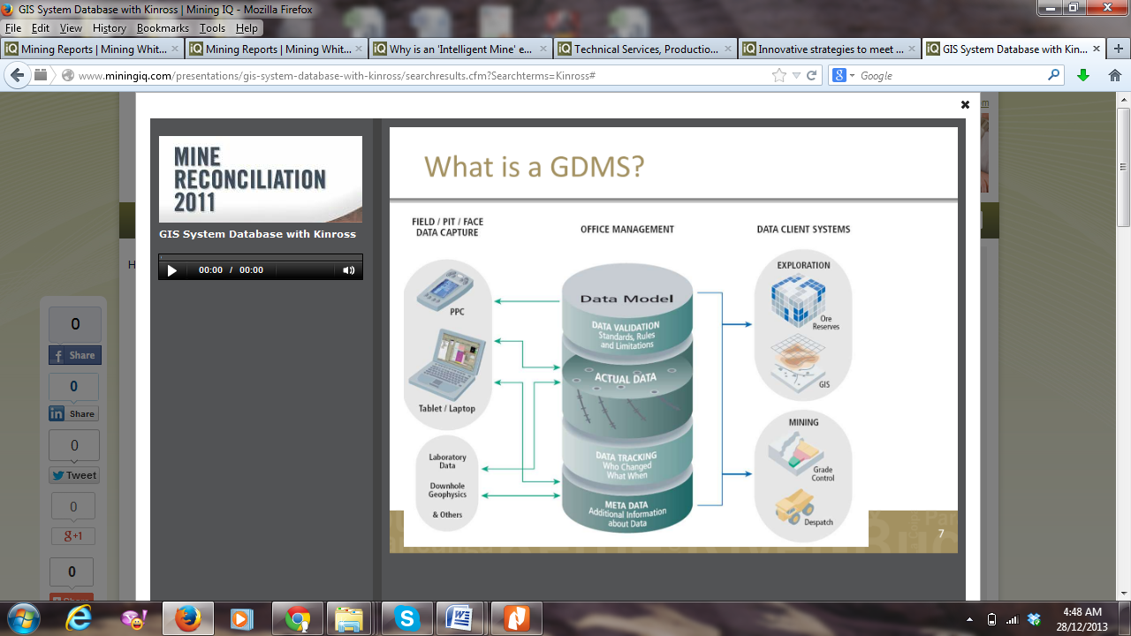
Figure 1: Geological Database system

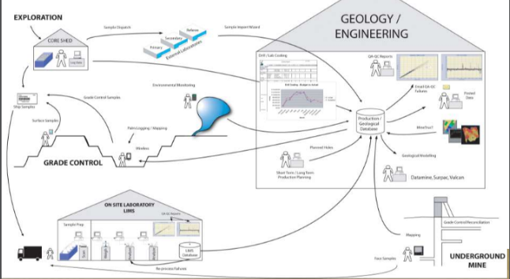
Figure 2: Geological and engineering data base linkage
Environmental Management
Kumba Iron Ore, has environmental monitoring system. Kumba Iron Ore developed an integrated environmental monitoring data management system for the Kolomela Mine in Postmasburg, South Africa. The system saves time by providing a one-stop shop for environmental monitoring data, such as water, dust, noise and biodiversity. An innovative hand held unit allows field data to be captured and automatically down loaded when the unit is docked, eliminating human error during data transfer. It allows sharing real time rehabilitation information dynamically with the environmental department (Idele,2013).
Petra Diamonds’ Finsch Mine in Lime Acres Northern Cape used mapping software as the source for GIS-related features implemented to share geospatial and attribute data with other departments in the mining operation. GIS will link and maintain the spatial data and information which is scattered in various databases (Idele,2013).
Remote Monitoring Solutions
The recent upgrades to the mobile phone network coverage and speed, combined with the internet backbone available, and even the satellite data communications infrastructure available today are creating an extensive and reliable communications infrastructure that is ideal for applications in mining. These technologies are providing a platform for the complete re-engineering of many business models in the Mining Industry.
Where water is discharged into multiple public waterways, regulations require the ongoing monitoring of water quality and flow-rate, and the regular reporting of this data to the authorities. This responsibility should fall outside of the production environment. Data should be secure and available for regular, but infrequent reporting, but abnormal events should be reported immediately to prevent pollution and possible fines from authorities.
The use of web-based remote monitoring provides a very convenient method of providing this data directly to the compliance office, without requiring large capital expenditure and access to internal technical resources. By providing a single web-enabled Data Access Point at each outflow location, data can be collected and provided in real-time to the compliance office. In addition, email and SMS alerts can be configured to provide immediate notification if water quality limits are breached (Celine,2013).
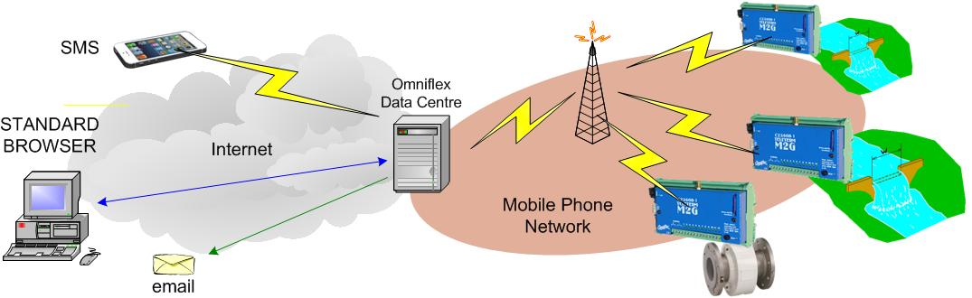
Figure3: Mine Dewatering Outflow Monitoring and Reporting
Drilling and Blasting

Information technology can be used in every step of drilling and blasting operations. Based on customized blast design tools for any operation blast design, charging and execution can be planned. The design can incorporate environmental restrictions and result goals. After holes are drilled then measurements regarding burden, spacing, hole depth need to be made either by using GPS or be measured manually. There would always be difference between designed hole location and inclination and actual holes drilled. After actual drilling and blasting parameters are available then predictive tools may be used for fragmentation, vibrations, flyrock and dust. Information can be used for simulation of firing sequence and for checking any unfired holes. If drilled blast is likely to exceed respective limits then charging, initiation timing and sequence can be changed to keep adverse environmental impacts within defined limits.

Figure 4: Blast information data management system

Drilling and blasting data management system ensures information storage, but also acts as an intelligent system as an aid for blast design, prediction of impacts and analysis. Data is obtained from blast hole face profiling tool, vibration prediction tool, and direct data link to a database incorporating all the major manufacturers products and an interface allowing the user to add new product ranges and create custom products. Misfire and accident details can be recorded (Bhandari,2011).

If data is continuously recorded then large number of data becomes available, the system can up-date scaled distance relationship, based on location variations and ultimately provide the blasting engineer with an interactive means to assist with planning of future blasts.

There is often difference in designed actual drilled data can be used for predicting environmental impact of blasting and if the environmental limits for vibration and flyrock imposed by regulatory authorities or by management exceed then explosive charge distribution and initiation timing and sequence can be changed so that limits are not exceeded.

A comprehensive blasting analysis and reporting software VIBRATION PREDICTOR meets the needs of both operators and regulators. It supports and improves compliance with blasting related planning conditions, and contributes to improved blast performance and blast design. Key features include:

Regular updating of predictions using ongoing site data, providing minimum instantaneous charge (MICs) to the operator that ensure compliance with vibration level restrictions by design rather than by accident. The system’s advanced analysis also allows blasting on individual benches or areas to be assessed and the financial and environmental risks and benefits of changes to be evaluated rapidly and reliably, optimising costs and maximising efficiency.

Analysis by wave front reinforcement predictor software has been found that many blast design and initiation cause substantial increases in both air and ground vibration from both surface and underground blasting operations. Simple alterations to firing patterns can prevent wave front reinforcement and be used to control vibration levels in many situations. By change of delay timing or sequence reinforcement can be avoided thus lowering of maximum vibration levels. This tool allows blast to be designed to reduce exceedance of vibrations both for airblast and for ground vibrations (Richards, 1995).

Inputs to flyrock prediction software are charge mass, burden or stemming height, and a site constant that lies within a general range that can be tightened by site calibration. The output is the distance that rock will be thrown, and this ‘design your own flyrock’ quantification can be used to establish both safe clearance distances, and the critical range of burdens and stemming heights where the situation changes rapidly from safe to hazardous.

Conclusion

The use of new technologies in the connected world is inevitable, as it provides the best-in-class means today of communicating with thousands of points securely and cost effectively. Information and communications technology can be applied to the entire value chain and lifecycle of mining and mineral extraction.

References:
- Akella, J. Kubach,T. Markus Löffler, and Uwe Schmid, Data-driven management: Bringing more science into management, McKinsey Technology Initiative Perspective, 2008.
- A special report on Managing information: Data, data everywhere, The Economist, February 25, 2010.
- Acquire, Fact Sheet Monitoring (www.acquire.com.au)
- Bhandari, S. “Information Management for Improved Blasting Operations and Environmental Control”; 3rd Asia- Pacific Symposium on Blasting Techniques, August 10-13, 2011 Xiamen, China
- Celine, D., Applying Remote Monitoring Solutions to improve Compliance and Efficiency in the Mining Industry, 2013 (www.omniflex.com/wplist.php)
- GIS/Database systems at Kinross, Mine Reconcilation 2011, November 2011.
- Idele, E. “On Back Burner”, Mining Weekly, June 2013: p 29.
- I2Mine, Innovative Technologies and concept for Intelligent deep mine of the future (www.i2mine.eu/)
- Leslile, McHattiee “Advances in Mine Engineering to enable Information Mobility for “Intelligent Mining”, A Bentley White Paper, May 2013.
- Richards, A. B. and Moore, A. J., 1995: Blast Vibration Control by Wavefront Reinforcement Techniques in Explo 1995, pp 323-327 (The Australasian Institute of Mining and Metallurgy in association with The International Society of Explosives Engineers: Brisbane).

